About Harrisburg Keystone
Rotary Club

The Harrisburg Keystone Rotary Club was chartered on September 16,
2005.

The Harrisburg-Keystone club embodies the spirit of Rotary International in the 21st Century while observing the traditions of the organization’s rich and fruitful past.
Our club started as a provisional club of the Harrisburg Rotary Club.

We are considered a “happy hour” club, itself a new concept for Rotary but one that seems to fit well with today’s on-the-go lifestyles.

We meet every Tuesday at the Appalachian Brewing Company in Harrisburg, PA and our members find it gives them a great opportunity to become involved while not intruding into their work or family time.

Other areas that make the Harrisburg Keystone club progressive are our membership and club activities. We have a diverse membership and prioritize getting out in the community with hands-on service projects.

We strive to use one meeting a month to participate at a volunteer project such as a local food bank, roadside cleanup, or assisting a variety of other organizations whose needs have been shared with us through our guest
speakers.

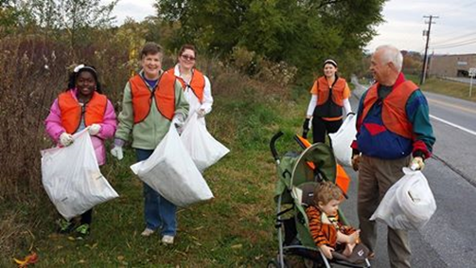

The Harrisburg-Keystone Rotary:

A great place and time to meet An exciting program of speakers and volunteer opportunities
A wonderful way to make new friends and make our community a better and more rewarding home for all of us
A chance to be a part of a world wide organization that truly makes a difference.

We invite you to join us for one of our meetings!
Whether you’re a visiting Rotarian looking for a worthwhile make-up meeting or you’re considering joining a service club and want to experience a Rotary club
first-hand, we look forward to seeing you at our next meeting.

What do we do?

Sing Christmas carols to people living in local nursing homes
Re-package BULK food items into smaller, "user-friendly" portions at the Central PA Foodbank
Provide free vision testing and eyewear to residents of Allison with the Vision Mission program.
Raise funds in a variety of ways to
support humanitarian projects – sponsoring a .5k fun run, making/selling
popcorn,
cotton candy, etc. at Hershey
Park,
Help with the Semi-Annual inventory sales of Dress For Success

What do we do?

Host Group Study Exchange Team
Members
Clean up a stretch of highway in Harrisburg, South 19th Street, near the Green Belt
Be a Team Leader for Group Study
Exchanges
Partner with the Guayquil South Rotary club in Ecuador to provide medical assistance to a neighborhood in south Guayquil.

Our goal: To make the world a better place - One life at a time!

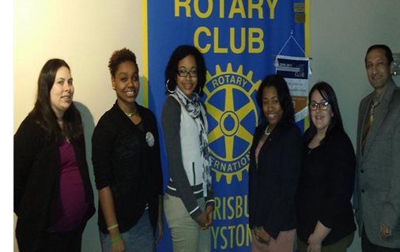

Updated February 2014

The Object of Rotary

The Object of Rotary is to encourage and foster the ideal of service as a basis of worthy enterprise.

Avenues of Service

Based on the Object of Rotary, the Avenues of Service are Rotary’s philosophical cornerstone and the foundation on which club activity is based:

Club Service Vocational Service Community Service International Service
New Generations Service

For more information, contact:

Tom Banks, Membership
Megan Mines-Hall, Membership
Alicia Duke, President

hkr7390@gmail.com

www.hbgkeystonerotary.org
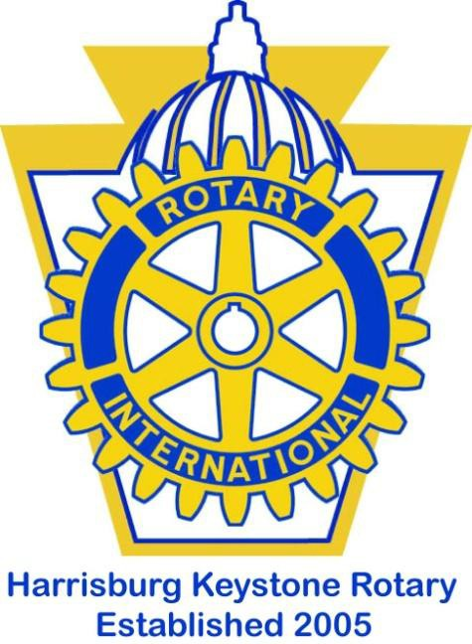

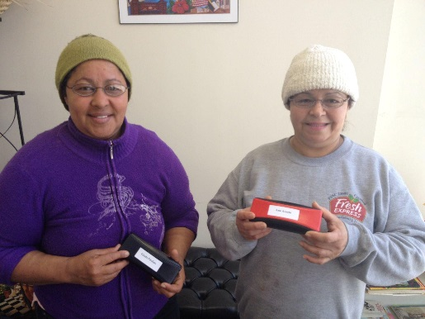

“Service Above Self”

Join us for meetings:
Every Tuesday
5:30pm – 6:30pm
Appalachian Brewing Company
50 N. Cameron St, Harrisburg PA

